Q1.
Lactose is the main sugar in milk and is hydrolysed by the enzyme lactase. Lactase is essential to newborn mammals as milk is their only source of food. Most mammals stop producing lactase when they start feeding on other food sources. Humans are an exception to this because some continue to produce lactase as adults. The ability to continue producing lactase is known as lactase persistence (LP) and is controlled by a dominant allele. A number of hypotheses based on different selection pressures have been put forward to explain LP in humans.
(a) One hypothesis for LP in humans suggests that the selective pressure was related to some human populations farming cattle as a source of milk.
Describe how farming cattle as a source of milk could have led to an increase in LP.
___________________________________________________________________
___________________________________________________________________
___________________________________________________________________
___________________________________________________________________
___________________________________________________________________
___________________________________________________________________
___________________________________________________________________
___________________________________________________________________
___________________________________________________________________
___________________________________________________________________
(4)
(b) Use the information provided to explain why the number of people showing LP would rapidly increase once selection for this condition had been established.
___________________________________________________________________
___________________________________________________________________
___________________________________________________________________
___________________________________________________________________
___________________________________________________________________
___________________________________________________________________
(2)
(c) Lactase persistence is caused by a mutation in DNA. This mutation does not occur in the gene coding for lactase.
Suggest and explain how this mutation causes LP.
___________________________________________________________________
___________________________________________________________________
___________________________________________________________________
___________________________________________________________________
___________________________________________________________________
___________________________________________________________________
(2)
(Total 8 marks)
Q2.
(a) What is a gene pool?
___________________________________________________________________
___________________________________________________________________
(1)
(b) Lord Howe Island in the Tasman Sea possesses two species of palm tree which have arisen via sympatric speciation. The two species diverged from each other after the island was formed 6.5 million years ago. The flowering times of the two species are different.
Using this information, suggest how these two species of palm tree arose by sympatric speciation.
___________________________________________________________________
___________________________________________________________________
___________________________________________________________________
___________________________________________________________________
___________________________________________________________________
___________________________________________________________________
___________________________________________________________________
___________________________________________________________________
___________________________________________________________________
___________________________________________________________________
(5)
(Total 6 marks)
Q3.
To reduce the damage caused by insect pests, some farmers spray their fields of crop plants with pesticide. Many of these pesticides have been shown to cause environmental damage.
Bt plants have been genetically modified to produce a toxin that kills insect pests. The use of Bt crop plants has led to a reduction in the use of pesticides.
Scientists have found that some species of insect pest have become resistant to the toxin produced by the Bt crop plants.
The figure below shows information about the use of Bt crops and the number of species of insect pest resistant to the Bt toxin in one country.
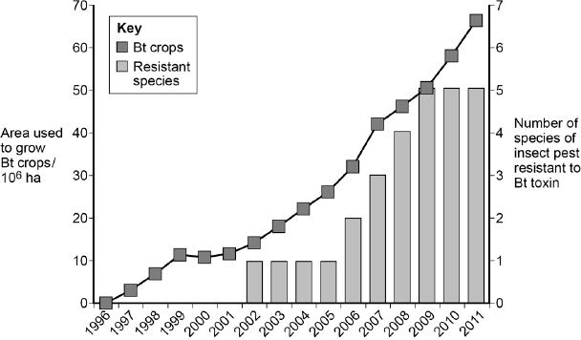
Year
(a) Can you conclude that the insect pest resistant to Bt toxin found in the years 2002 to 2005 was the same insect species? Explain your answer.
___________________________________________________________________
___________________________________________________________________
(1)
(b) One farmer stated that the increase in the use of Bt crop plants had caused a mutation in one of the insect species and that this mutation had spread to other species of insect. Was he correct? Explain your answer.
___________________________________________________________________
___________________________________________________________________
___________________________________________________________________
___________________________________________________________________
___________________________________________________________________
___________________________________________________________________
___________________________________________________________________
___________________________________________________________________
(4)
(c) There was a time lag between the introduction of Bt crops and the appearance of the first insect species that was resistant to the Bt toxin.
Explain why there was a time lag.
___________________________________________________________________
___________________________________________________________________
___________________________________________________________________
___________________________________________________________________
___________________________________________________________________
___________________________________________________________________
(3)
(Total 8 marks)
Q4.
Malaria is a disease that is spread by insects called mosquitoes. In Africa, DDT is a pesticide used to kill mosquitoes, to try to control the spread of malaria.
Mosquitoes have a gene called KDR. Today, some mosquitoes have an allele of this gene, KDR minus, that gives them resistance to DDT. The other allele, KDR plus, does not give resistance.
Scientists investigated the frequency of the KDR minus allele in a population of mosquitoes in an African country over a period of 10 years.
The figure below shows the scientists’ results.
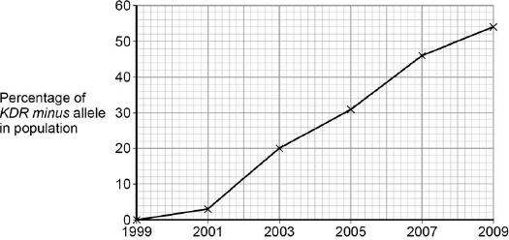
Year
(a) Use the Hardy–Weinberg equation to calculate the frequency of mosquitoes heterozygous for the KDR gene in this population in 2003.
Show your working.

Frequency of heterozygotes in population in 2003 ____________________
(2)
(b) Suggest an explanation for the results in the figure above.
___________________________________________________________________
___________________________________________________________________
___________________________________________________________________
___________________________________________________________________
___________________________________________________________________
___________________________________________________________________
___________________________________________________________________
___________________________________________________________________
(4)
The KDR plus allele codes for the sodium ion channels found in neurones.
(c) When DDT binds to a sodium ion channel, the channel remains open all the time.
Use this information to suggest how DDT kills insects.
___________________________________________________________________
___________________________________________________________________
___________________________________________________________________
___________________________________________________________________
(2)
(d) Suggest how the KDR minus allele gives resistance to DDT.
___________________________________________________________________
___________________________________________________________________
___________________________________________________________________
___________________________________________________________________
(2)
(Total 10 marks)
Q5.
There are wolves in many European countries. Scientists investigated the genetic diversity of these wolves. They collected samples of DNA from the mitochondria of wolves from different countries. For each sample they identified which haplotypes were present in the DNA. A haplotype is a particular sequence of bases on DNA. Mutations can produce new haplotypes.

Country | Number of wolves  sampled | Number of different  haplotypes in  mitochondrial DNA
Spain | 84 | 3
Portugal | 19 | 2
Italy | 101 | 1
France | 7 | 1
Bulgaria | 29 | 6
Sweden | 93 | 1
The scientists wanted to find out whether one of the haplotypes in the Portuguese wolves was the same as one of those in the Spanish wolves. They used a restriction endonuclease, electrophoresis and a labelled DNA probe.
(a) For what purpose did they use
(i) the restriction endonuclease
______________________________________________________________
______________________________________________________________
(1)
(ii) electrophoresis?
______________________________________________________________
______________________________________________________________
(1)
(b) Explain why the labelled DNA probe could be used to find out whether the haplotypes were the same.
___________________________________________________________________
___________________________________________________________________
___________________________________________________________________
___________________________________________________________________
(2)
(c) The scientists analysed the DNA on the Y chromosome and the DNA in the mitochondria of the Swedish wolves. They concluded that the Swedish wolf population descended from one male wolf from Finland and one female wolf from Russia.
(i) Explain why DNA on the Y chromosome helped them to reach this conclusion.
______________________________________________________________
______________________________________________________________
(1)
(ii) Suggest why DNA in the mitochondria helped them to reach this conclusion.
______________________________________________________________
______________________________________________________________
(1)
Wolves eat different mammals. An ecologist investigated factors that affect wolf numbers in North America. He collected data from different field studies carried out in different places. The graph shows his results.
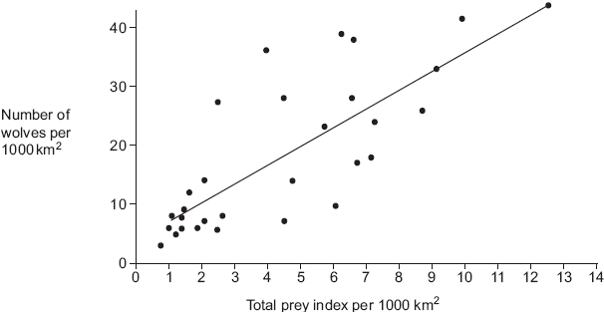
(d) (i) The wolf numbers are given per unit area. Explain why.
______________________________________________________________
______________________________________________________________
______________________________________________________________
______________________________________________________________
(2)
(ii) The ecologist calculated the total prey index for each of the places that had been studied. In order to do this, he gave each prey species a value based on how much food was available to wolves from the prey animal concerned. He called this value the prey index.
The ecologist considered that the prey index gave a better idea of the food available than the prey biomass in kg. Suggest why the prey index gives a better idea of food available.
______________________________________________________________
______________________________________________________________
______________________________________________________________
______________________________________________________________
(2)
(e) The ecologist calculated the total prey index by combining the prey indices and the total number of animals of each species present in 1000 km². He plotted this information on the graph. What does the graph suggest about the factors that determine wolf numbers in North America? Explain your answer.
___________________________________________________________________
___________________________________________________________________
___________________________________________________________________
___________________________________________________________________
(2)
(Total 12 marks)
Q6.
Ecologists studied a community of fish in a lake.
(a) Explain what is meant by a community.
___________________________________________________________________
___________________________________________________________________
___________________________________________________________________
(1)
(b) (i) The ecologists could have used the mark-release-recapture method to estimate the number of one species of fish in the lake. Describe how.
______________________________________________________________
______________________________________________________________
______________________________________________________________
______________________________________________________________
______________________________________________________________
______________________________________________________________
(3)
(ii) This species of fish breeds at a certain time of the year. During this fish-breeding season, the mark-release-recapture technique might not give a reliable estimate.
Suggest one reason why.
______________________________________________________________
______________________________________________________________
______________________________________________________________
(1)
(c) The ecologists found that each species of fish had adaptations to its niche. One of these adaptations was the shape of its mouth.
Suggest how the shape of mouth is an adaptation to its niche.
___________________________________________________________________
___________________________________________________________________
___________________________________________________________________
___________________________________________________________________
___________________________________________________________________
(2)
(Total 7 marks)
Q7.
There are nine subspecies of giraffe. These subspecies evolved when populations of giraffe were separated for long time periods. Each subspecies has distinct coloured skin markings. Some biologists have suggested that up to six of these subspecies should be classified as different species.
(a) Explain how different subspecies of giraffe may have evolved from a common ancestor.
Use information from the passage in your answer.
___________________________________________________________________
___________________________________________________________________
___________________________________________________________________
___________________________________________________________________
___________________________________________________________________
___________________________________________________________________
___________________________________________________________________
___________________________________________________________________
___________________________________________________________________
___________________________________________________________________
___________________________________________________________________
(5)
(b) Biologists compared the mitochondrial DNA of the different subspecies of giraffe. They used the results from comparing this DNA to conclude that six of the nine subspecies are separate species.
Suggest how they came to this conclusion.
___________________________________________________________________
___________________________________________________________________
___________________________________________________________________
___________________________________________________________________
___________________________________________________________________
(2)
(Total 7 marks)
Q8.
Malaria is a disease that destroys red blood cells. Scientists investigated whether certain red blood cell phenotypes were associated with developing severe or mild malaria. They compared the red blood cell phenotypes of hospital patients suffering from severe malaria with the red blood cell phenotypes of patients suffering from mild malaria. The results are shown in the table.

Red blood cell phenotype | Ratio of patients with  severe malaria : patients  with mild malaria
Sickle cell trait | 0.48 : 1
Blood group A | 2.45 : 1
Blood group O | 0.96 : 1
(a) Explain the advantage of presenting the results as a ratio.
___________________________________________________________________
___________________________________________________________________
___________________________________________________________________
___________________________________________________________________
___________________________________________________________________
(2)
(b) What do these data show about the effect of red blood cell phenotypes on the chance of developing severe malaria rather than mild malaria?
___________________________________________________________________
___________________________________________________________________
___________________________________________________________________
___________________________________________________________________
(2)
(c) The allele for normal haemoglobin in red blood cells is Hb^{A}. In some parts of Africa where malaria occurs there is a high frequency in the population of the allele Hb^{C}.
Individuals possessing the Hb^{C} allele have a lower chance of developing severe malaria. Severe malaria causes a large number of deaths in Africa.
Explain the high frequency of the Hb^{C} allele in areas where malaria occurs.
___________________________________________________________________
___________________________________________________________________
___________________________________________________________________
___________________________________________________________________
___________________________________________________________________
___________________________________________________________________
(3)
(Total 7 marks)
Q9.
Schizophrenia is a mental illness. Doctors investigated the relative effects of genetic and environmental factors on the development of schizophrenia. They used sets of identical twins and non-identical twins in their investigation. At least one twin in each set had developed schizophrenia.
• Identical twins are genetically identical.
• Non-identical twins are not genetically identical.
• The members of each twin pair were raised together.
The table shows the percentage of cases where both twins had developed schizophrenia.

Type of twin | Percentage of cases where both twins had developed schizophrenia
Identical | 50
Non-identical | 15
(i) Explain why both types of twin were used in this investigation.
___________________________________________________________________
___________________________________________________________________
___________________________________________________________________
___________________________________________________________________
___________________________________________________________________
(2)
(ii) What do these data suggest about the relative effects of genetic and environmental factors on the development of schizophrenia?
___________________________________________________________________
___________________________________________________________________
___________________________________________________________________
(1)
(iii) Suggest two factors that the scientists should have taken into account when selecting the twins to be used in this study.
1. _________________________________________________________________
2. _________________________________________________________________
(2)
(Total 5 marks)
Q10.
(a) Energy enters most ecosystems through the light-dependent reaction of photosynthesis. Describe what happens during the light-dependent reaction.
___________________________________________________________________
___________________________________________________________________
___________________________________________________________________
___________________________________________________________________
___________________________________________________________________
___________________________________________________________________
___________________________________________________________________
___________________________________________________________________
___________________________________________________________________
___________________________________________________________________
(5)
(b) Changes in ecosystems can lead to speciation. A high concentration of copper in soil is toxic to most plants. In some areas where the soil is polluted with copper, populations of grasses are found to be growing. These populations of grass belong to a species also found growing on unpolluted soils.
It has been suggested that a new species of grass may evolve on soil that has been polluted with copper. Explain how this new species might evolve.
___________________________________________________________________
___________________________________________________________________
___________________________________________________________________
___________________________________________________________________
___________________________________________________________________
___________________________________________________________________
___________________________________________________________________
___________________________________________________________________
___________________________________________________________________
___________________________________________________________________
(5)
(Total 10 marks)

